Experiment No. 3: Device Onboarding and Data Flow in AWS IoT Core (Google Colab Simulation)

AIM
To simulate the onboarding of a smart parking IoT device and the transmission of parking occupancy data through a cloud-based workflow similar to AWS IoT Core using Python in Google Colab.

SOFTWARE REQUIRED
- Google Colab
- Python 3
- pandas
- NumPy
- matplotlib

Procedure
- Open Google Colab and create a new notebook.
- Import the required Python libraries such as Pandas and Matplotlib.
- Register the smart parking IoT device by assigning a unique device ID.
- Simulate the authentication process to verify the registered device.
- Generate smart parking occupancy data representing the number of occupied parking slots over time.
- Create a pandas DataFrame to store the generated parking occupancy data.
- Simulate the transmission of parking occupancy data to the cloud.
- Perform cloud-based analytics by calculating the average parking occupancy.
- Detect parking congestion by comparing the occupied parking slots with the predefined congestion threshold.
- Display the parking occupancy dataset along with the congestion status.
- Save the processed parking occupancy data as a CSV file for future analysis.
- Visualize the parking occupancy data using a line graph and highlight congestion points with a threshold line.
- Observe the output and conclude the experiment.

THEORY
AWS IoT Core is a cloud platform that enables secure communication between Internet of Things (IoT) devices and cloud services. It allows devices to be registered, authenticated, and connected to the cloud for real-time data exchange, storage, monitoring, and analytics.
In a smart parking system, parking sensors continuously collect occupancy information and transmit it to the cloud. The cloud processes the incoming data, performs analytics to monitor parking availability, detects congestion when occupancy becomes high, and stores the data for future analysis.
Since implementing AWS IoT Core requires an AWS account, IoT certificates, and cloud resources, this experiment uses Google Colab to simulate the complete workflow, including device onboarding, authentication, cloud data transmission, analytics, congestion detection, visualization, and data storage.

Typical AWS IoT Core Data Flow
IoT Device
│
▼
Device Authentication
│
▼
AWS IoT Core (Simulated)
│
▼
Cloud Data Storage
│
▼
Cloud Analytics & Dashboard
Phython code:
# Experiment 3: Device Onboarding and Data Flow in AWS IoT Core (Simulation)

import pandas as pd
import matplotlib.pyplot as plt

# -----------------------------------
# Step 1: Device Registration
# -----------------------------------
device_id = "Parking_Sensor_001"
print("Device Registered Successfully")
print("Device ID:", device_id)

# -----------------------------------
# Step 2: Device Authentication
# -----------------------------------
print("\nAuthenticating Device...")

authenticated = True

if authenticated:
print("Authentication Successful\n")
else:
print("Authentication Failed")

# -----------------------------------
# Step 3: Generate Parking Data
# -----------------------------------

time = [1,2,3,4,5,6,7,8,9,10]

occupied_slots = [20,25,30,35,40,45,48,50,32,28]

total_slots = 50

# Create DataFrame
df = pd.DataFrame({
"Time": time,
"OccupiedSlots": occupied_slots
})

# -----------------------------------
# Step 4: Cloud Analytics
# -----------------------------------

mean_occupancy = df["OccupiedSlots"].mean()

print("Average Occupancy =", mean_occupancy)

# Congestion Detection
df["Status"] = df["OccupiedSlots"].apply(
lambda x: "Congested" if x >= 45 else "Normal"
)

print("\nParking Data")
print(df)

# -----------------------------------
# Step 5: Save CSV
# -----------------------------------

df.to_csv("parking_data.csv", index=False)

print("\nCSV File Saved Successfully")

# -----------------------------------
# Step 6: Plot Graph
# -----------------------------------

plt.figure(figsize=(8,5))

plt.plot(df["Time"],
df["OccupiedSlots"],
marker='o',
linewidth=2,
label="Occupied Slots")

# Congested Points
congested = df[df["OccupiedSlots"] >= 45]

plt.scatter(congested["Time"],
congested["OccupiedSlots"],
color='red',
s=120,
label="Congestion")

# Threshold
plt.axhline(y=45,
color='orange',
linestyle='--',
label="Congestion Threshold")

plt.title("Smart Parking Occupancy Monitoring")
plt.xlabel("Time")
plt.ylabel("Occupied Parking Slots")
plt.grid(True)
plt.legend()

plt.show()

print("\nExperiment Completed Successfully")

Output:
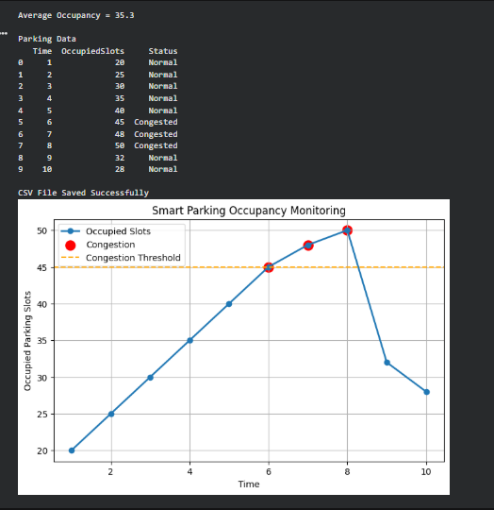

RESULT
The smart parking IoT device was successfully onboarded and authenticated in the simulated AWS IoT Core environment. Parking occupancy data was generated, transmitted to the simulated cloud, analyzed to monitor occupancy and detect congestion, visualized using graphs, and stored successfully for future analysis using Python in Google Colab.

